1. Merge Two Sorted Lists

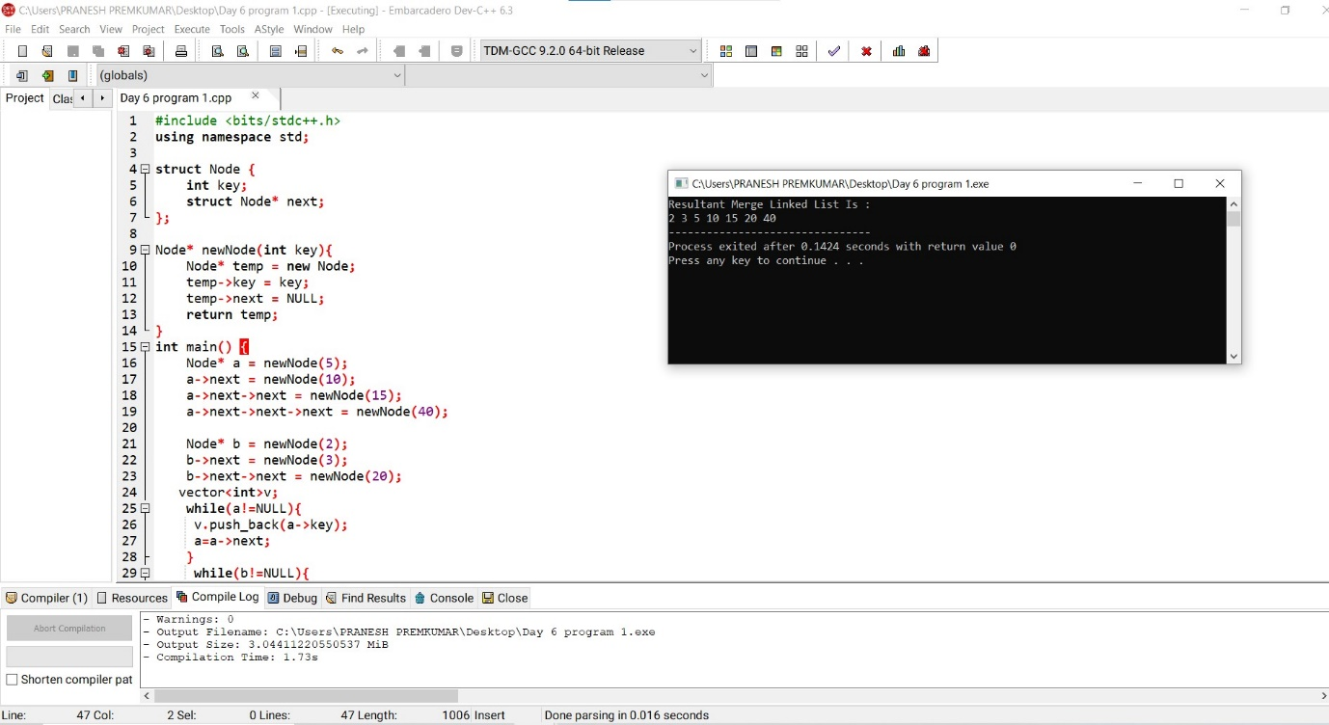

2. Merge k Sorted Lists

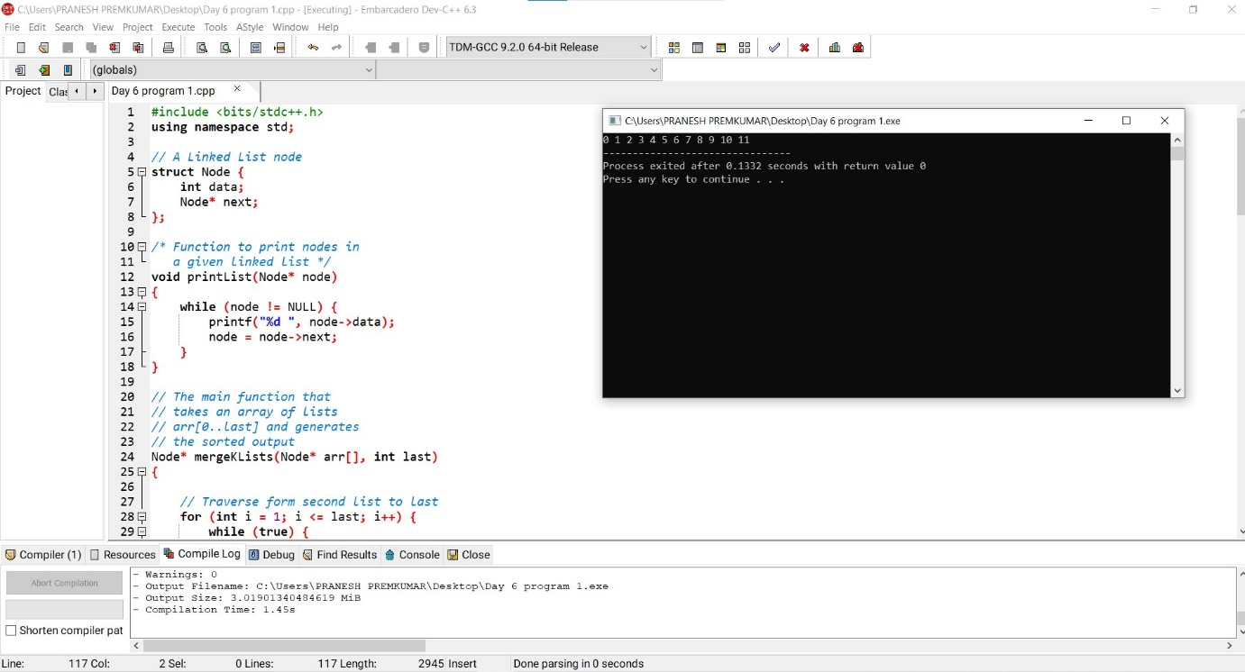

3. Remove Duplicates from Sorted Array

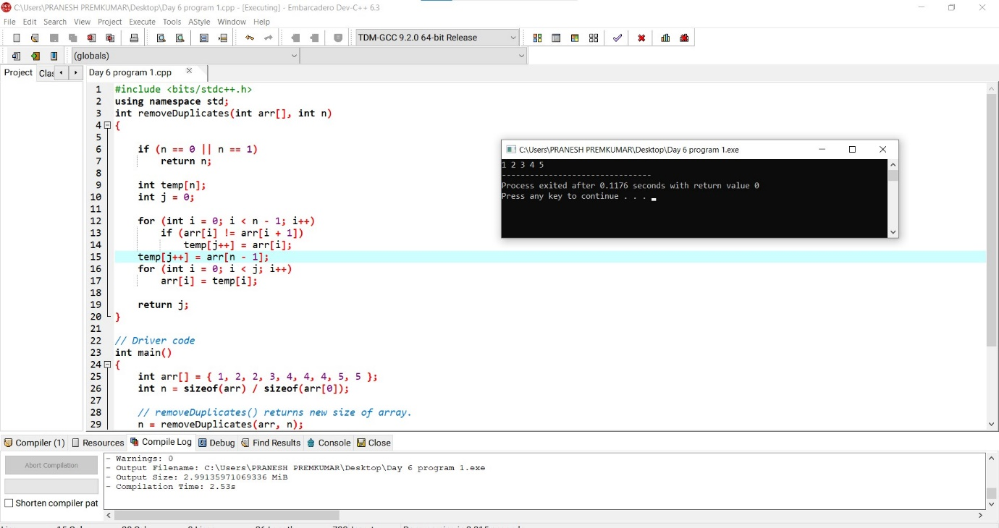

4. Search in Rotated Sorted Array

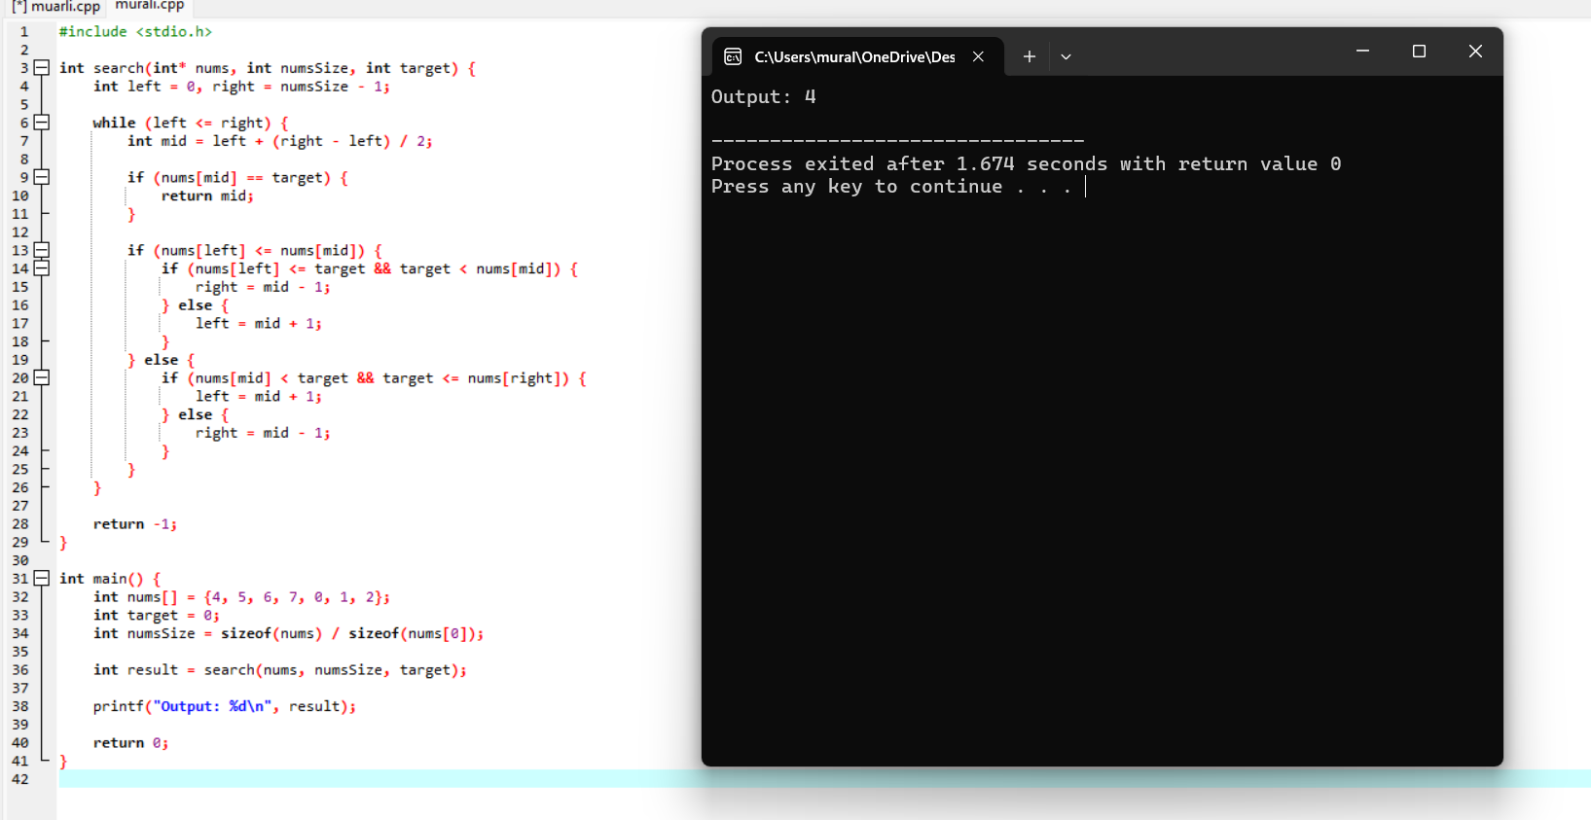

5. Find First and Last Position of Element in Sorted Array

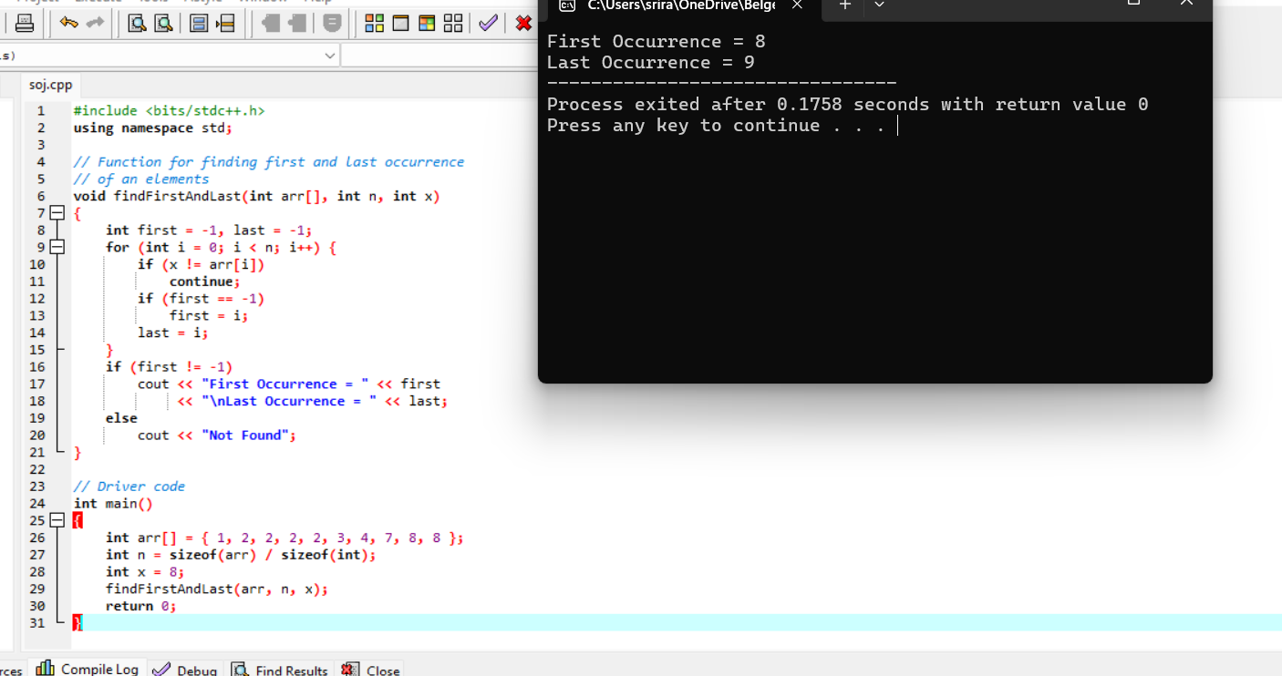

6. Sort Colors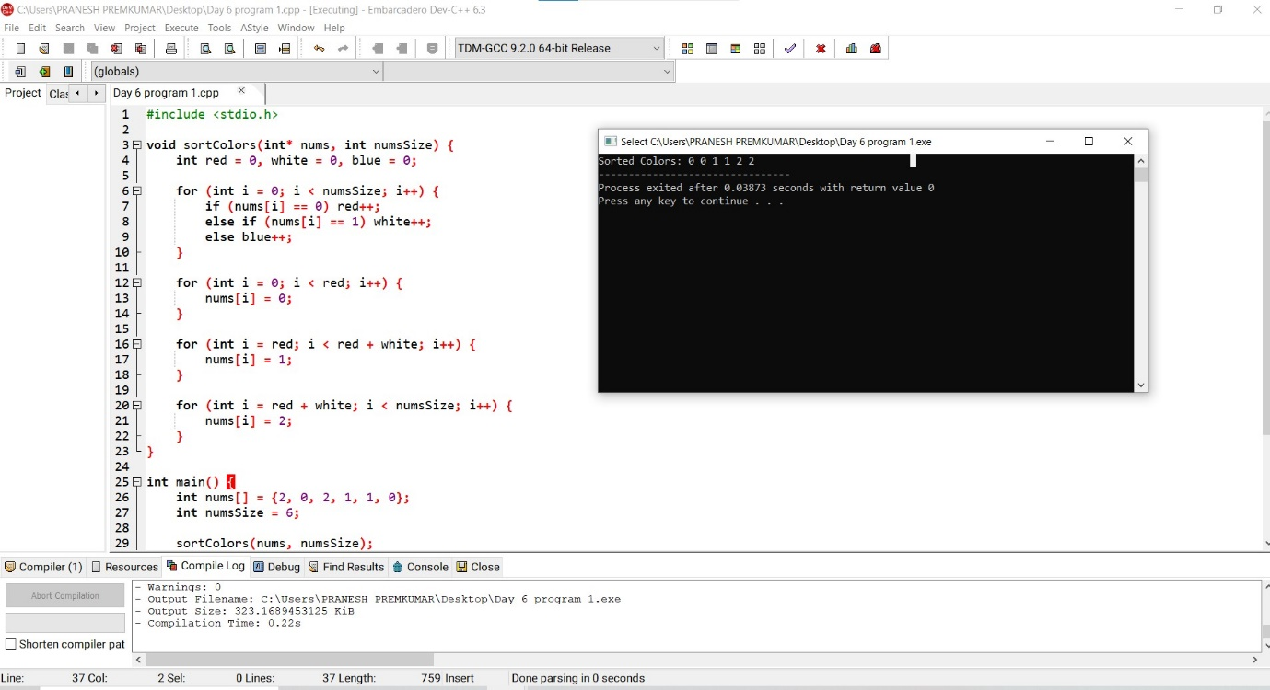

7. Remove Duplicates from Sorted List

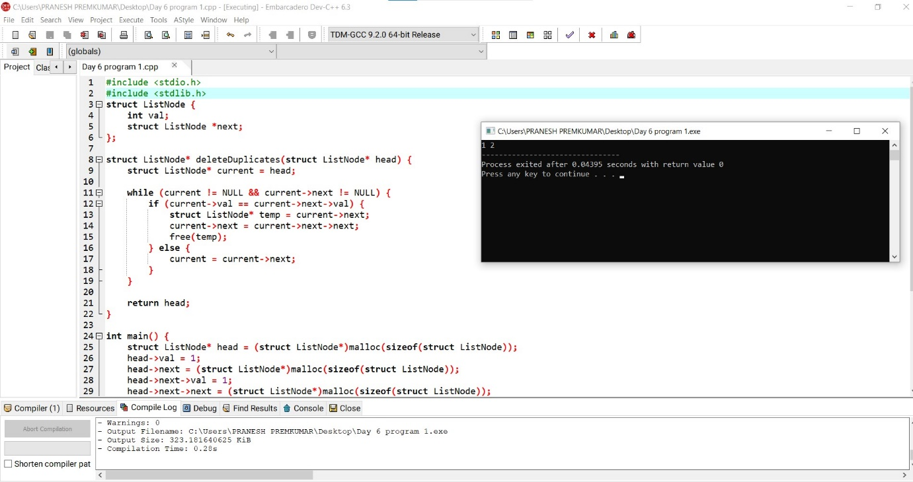

8. Merge Sorted Array

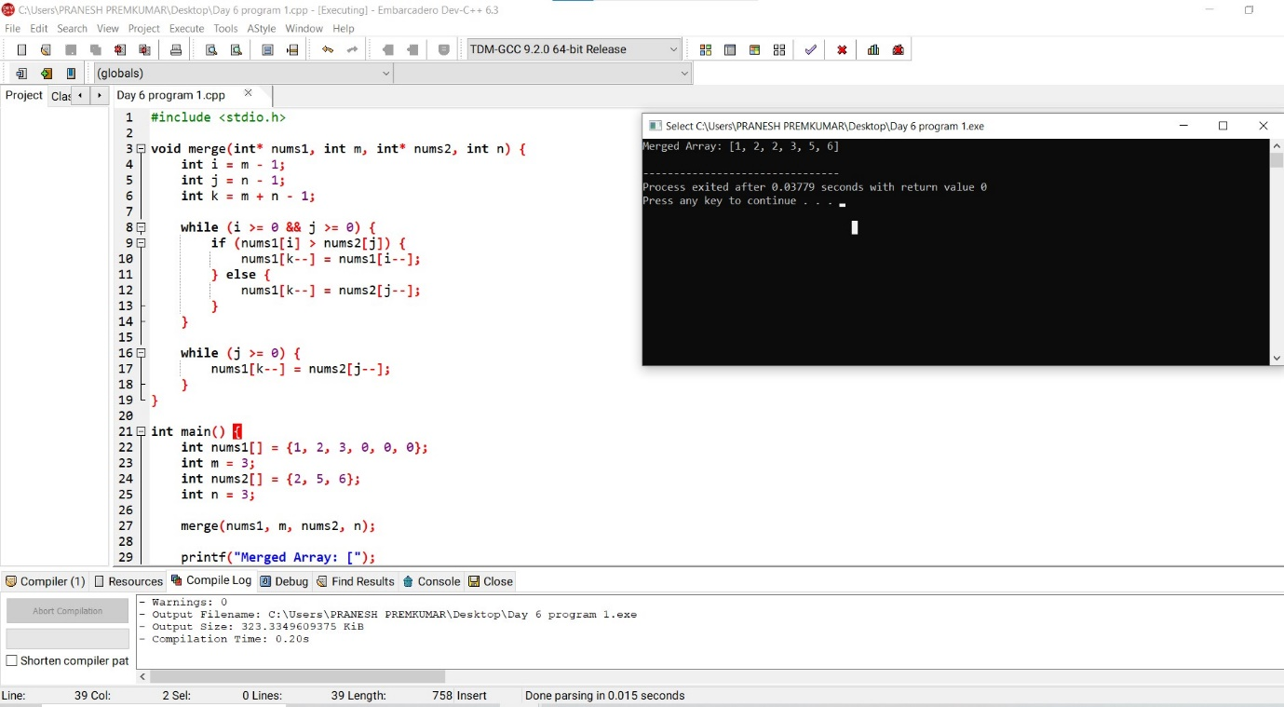

9. Convert Sorted Array to Binary Search Tree

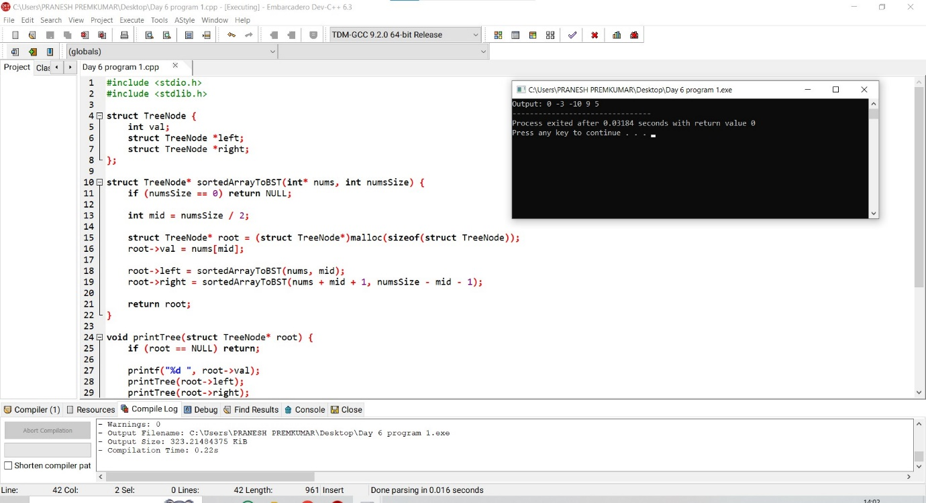

10. Insertion Sort List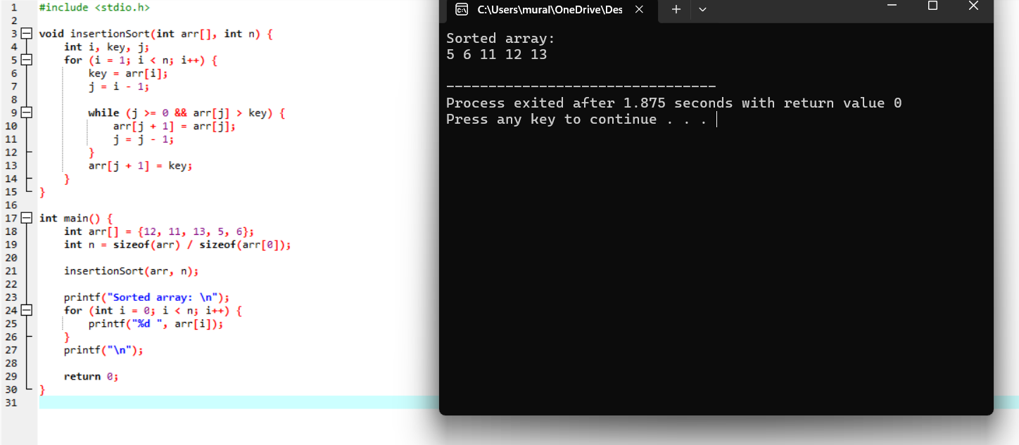

11. . Sort Characters By Frequency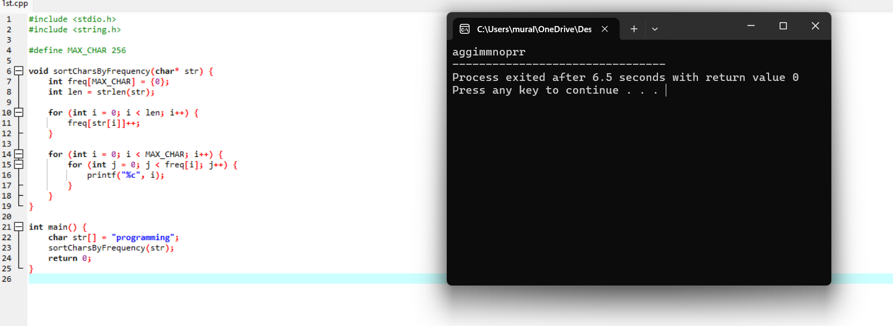

12. Max Chunks To Make Sorted

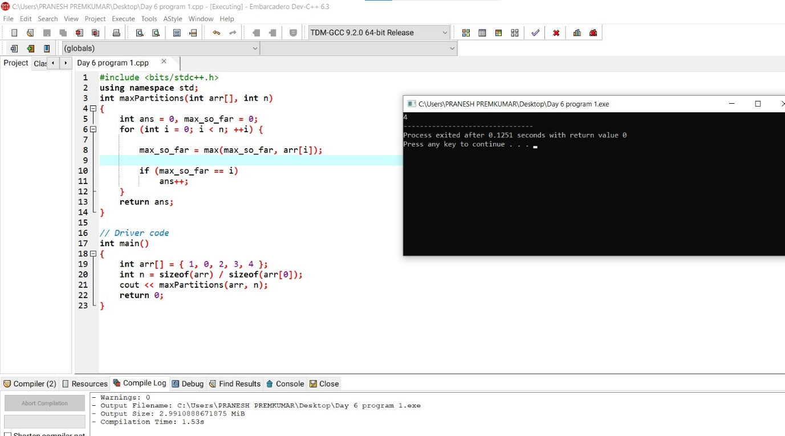

13. Intersection of Three Sorted Arrays

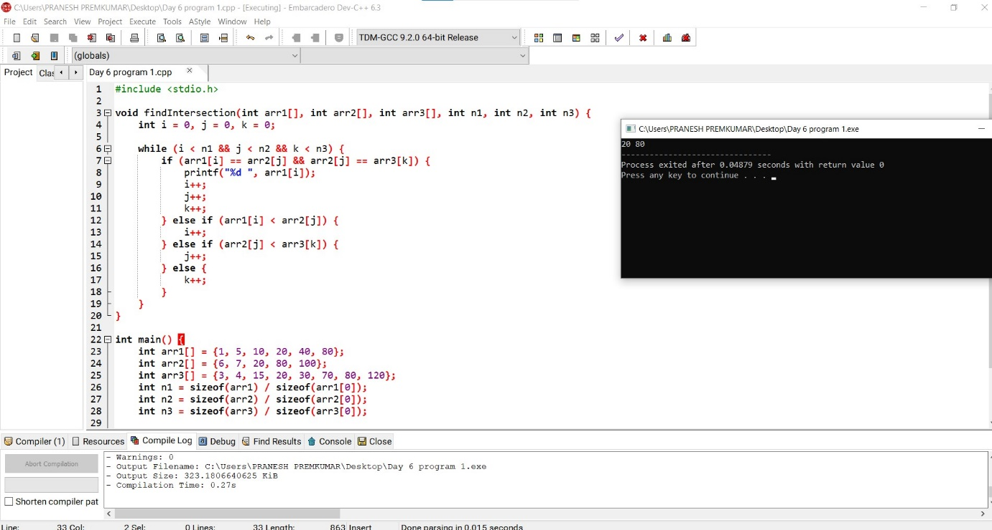

14. Sort the Matrix Diagonally

